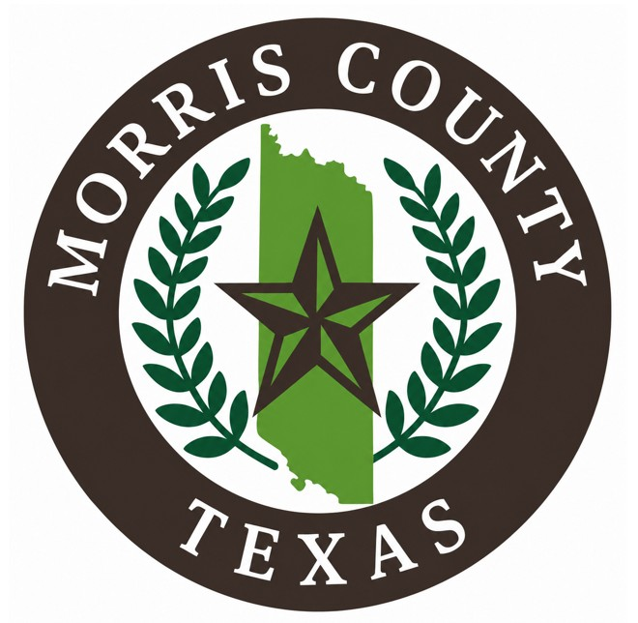

MORRIS COUNTY INDIGENT HEALTHCARE PROGRAM
APPLICATION

Vicki Jones – County Indigent Healthcare Coordinator
500 Broadnax, Ste. B, Daingerfield, TX 75638
Phone: (903) 645-3691
Fax: (903) 645 5729
Vicki.jones@co.morris.tx.us

Please keep pages 1 – 7 for future reference

ABOUT THE PROGRAM

Morris County’s Indigent Healthcare Program is the payor of last resort for eligible Morris County community members who meet the program’s eligibility criteria. The Indigent Healthcare Program is administered based on Chapter 61 Indigent Health Care and Treatment Act. Covered services must be medically necessary and provided by a member of the medical community who will accept the program.

Since the program is the payor of last resort, applicants and clients will be required to seek and accept any income or other benefits they are legally entitled to, such as, but not limited to, programs with Health Human Services Commissioner (Medicaid or Temporary Aid to Needy Families (TANF), Social Security Administration programs (SSI, SSDI, Survivors and /or Retirement Benefits), Crime Compensation, and Veteran’s Administration.

ELIGIBILITY CRITERIA

- RESIDENCE: The applicant must live in the county in which he/she applies and must intend to remain there. Applicants may not move to the county for the program.
- HOUSEHOLD: A CIHCP household is a person living alone or two or more persons living together where legal responsibility for support exists, excluding disqualified persons. A disqualified person is one who receives or is categorically eligible to receive Medicaid.
- RESOURCES: A household is eligible if the total countable household resources do not exceed $3,000 when a person who is aged or disabled and who meets relationship requirements lives in the home or $2,000 for all other households.
- INCOME:
- A household is eligible if its monthly net income (unearned income) does not exceed 21% of the Federal Poverty Guideline (FPG)
- A household is eligible if its monthly net income (earned income) does not exceed 50% of the Federal Poverty Guideline (FPG)

PLEASE NOTE, IN ORDER TO QUALIFY FOR MORRIS COUNTY INDIGENT HEALTHCARE PROGRAM BENEFITS, YOU MUST PROVIDE PROOF OF ONE OF THE FOLLOWING:

- BE DISABLED AND HAVE APPLIED, BEEN DENIED OR IN THE PROCESS OF APPEALING SSI (DISABILTY) BENEFITS WITH THE SOCIAL SECURITY ADMINISTRATION
Located at 2304 West Furguson Road, Mt. Pleasant, Tx
Phone: (877) 701-2138
https://www.ssa.gov/

- REGISTERED FOR WORK WITH TEXAS WORKFORCE CENTER.
312 N. Riddle, Mt. Pleasant Texas
Phone: (903)572-9841
Fax (903) 572-0159
https://www.netxworkforce.org/
*There is also a TWC kiosk available in the courthouse lobby

MORRIS COUNTY INDIGENT HEALTH CARE
APPLICATION REQUIREMENTS
The Morris County Indigent Health Care Program (MCIHCP) requires that all blank spaces on the application be completed at the time of submission. Applications that are incomplete or without the required information will result in your application being denied or returned to you.
The following information, as it applies to you, is required:
MARITAL STATUS: Single • Separated • Married • Divorced • Widowed
PROOF OF IDENTIFICATION for each applicant:
Texas Driver's License or Texas ID Card
Resident Alien Card/Visa/Passport/Work Permit
Social Security Card, if available
Current identification from your home country
ALL FORMS OF IDENTIFICATION MUST BE CURRENT ANO UP-TO-DATE
PROOF OF RESIDENCE IN MORRIS COUNTY
• Texas Driver's License or Texas ID with same address as your application
• Voter's Registration Card with same address as your application
• Current utility bill showing the same address as on your application (regardless of name on bill — so long as you are living there)
INCOME
• Four (4) most recent paycheck stubs (NOTE: if you have unpaid medical bills from the past 3 months, then we need all paycheck stubs for those months as well.)
• If paid in cash, you must bring a statement from your employer verifying your income. If self-employed, bring current records or self-employment form
- Current Social Security award letter for you, your spouse, and any children receiving it
• Current verification for Worker's Compensation medical benefits OR denial of benefits
- Current proof of any fixed income, such as: widow's benefits, retirement, pension, dividend payments, unemployment. worker's compensation, etc.
RESOURCES
• Bank statements for checking or savings accounts; verification of stock, bond, or retirement accounts
• Automobile registration or title for all vehicles in the household and loan information if applicable
VERIFICATION OF OTHER ASSISTANCE
• Current award/denial letters for Medicaid, TANF, SSI, Housing, Food Stamps or any other assistance program (bring all that apply)

MORRIS COUNTY INDIGENT HEALTHCARE PROGRAM
BASIC HEALTHCARE SERVICES ARE:
- Physician services- include services ordered and performed by a physician that are within the scope of practice of their profession as defined by state law
- Annual physical examinations – examinations provided once per calendar year by a physician or a physician assistant. Associated testing, such as mammograms, can be covered with a physician referral
- Immunizations- given when appropriate
- Medical screening services- include blood pressure, blood sugar, and cholesterol screening
- Laboratory and X-ray services – professional and technical service ordered and provided under the personal supervision of a physician in a setting other than a hospital (inpatient or outpatient)
- Family planning services – preventive health care services that assist an individual in controlling fertility and achieving optimal reproductive and general health.
- Skilled nursing facility services – must be medically necessary, ordered by a physician, and provided in the SNF that provides daily services on an inpatient basis.
- Prescription drugs – 3 per month (excluding controlled substances and anti-depressants)
- Rural health clinic services -services must be provided in a freestanding or hospital -based rural health clinic by physician, a physician assistant, and advanced practice nurse, or a visiting nurse
- Inpatient hospital services – must be medically necessary and provided in an acute care hospital to hospital inpatients, by on under the direction of a physician, and for the care and treatment of patients.
- Outpatient hospital services – must be medically necessary and provided in an acute care hospital to hospital outpatients, by or under the direction of a physician, and for the care and treatment of patients
- Vision care – ONLY if diabetes related, glaucoma, or cataracts

SPECIFIC SERVICES NOT COVERED

- We do not cover cancer treatment but will cover costs for tests
- We do not cover rehab outside of the hospital
- We do not cover joint replacements of any kind
- We do not cover any dental
- We do not cover co-pays or deductibles for other programs or insurance

We pay Medicaid Rates. The maximum county liability for each state fiscal year for health care services provided by all assistance providers, including hospital and skilled nursing facility, to each eligible county resident is:
- $30,000; or
- the payment of 30 days of hospitalization or treatment in a skilled nursing facility, or both, or $30,000, whichever occurs first, if the county provides hospital or skilled nursing facility services to the resident. Thirty days of hospitalization refers to inpatient hospitalization. Use the client’s actual dates-of-service when determining which fiscal year to apply the maximum county liability.

For the claim payment to be considered, a claim should be received:
- within 95 days from the approval date for services provided before the household was approved;
- within 95 days from the date of service for services provided after the approval date; or
- within the agreed time frame in a legal contract between the providers and the local indigent program.
- All claims must be submitted on a form CM1500 or UB04
- The payment standard is determined by the date the claim is paid.

PRESCRIPTIONS
Morris County Indigent Healthcare Program covers a limit of three (3) prescriptions per month.
- Prescriptions are limited to a 30-day supply. This is set by the State of Texas.
If the pharmacy accidentally fills a 60- or 90-day supply, it will count against the three per month.
- You cannot request or demand that anything over 30 days be filled.
- The following are not covered by the Program:
- Over-the Counter items/medications
- Controlled substances
- Anti-depressants
Currently, the following pharmacies accept our program:
Thurman’s Pro-Med Pharmacy
402 North Madison Avenue
Mt. Pleasant, TX 75455
(903) 572-6337

Thurman’s Pro-Med Pharmacy
201 Main Street
Naples, TX 75568
(903) 897-0011

Morris Care Pharmacy
213 W Scurry St., Ste C
Daingerfield, TX 75638
(903)289-1900

Powers Pharmacy
702 West Houston
Linden, TX 75563
(903)756-7923

ASSISTANCE AVAILABLE IN MORRIS COUNTY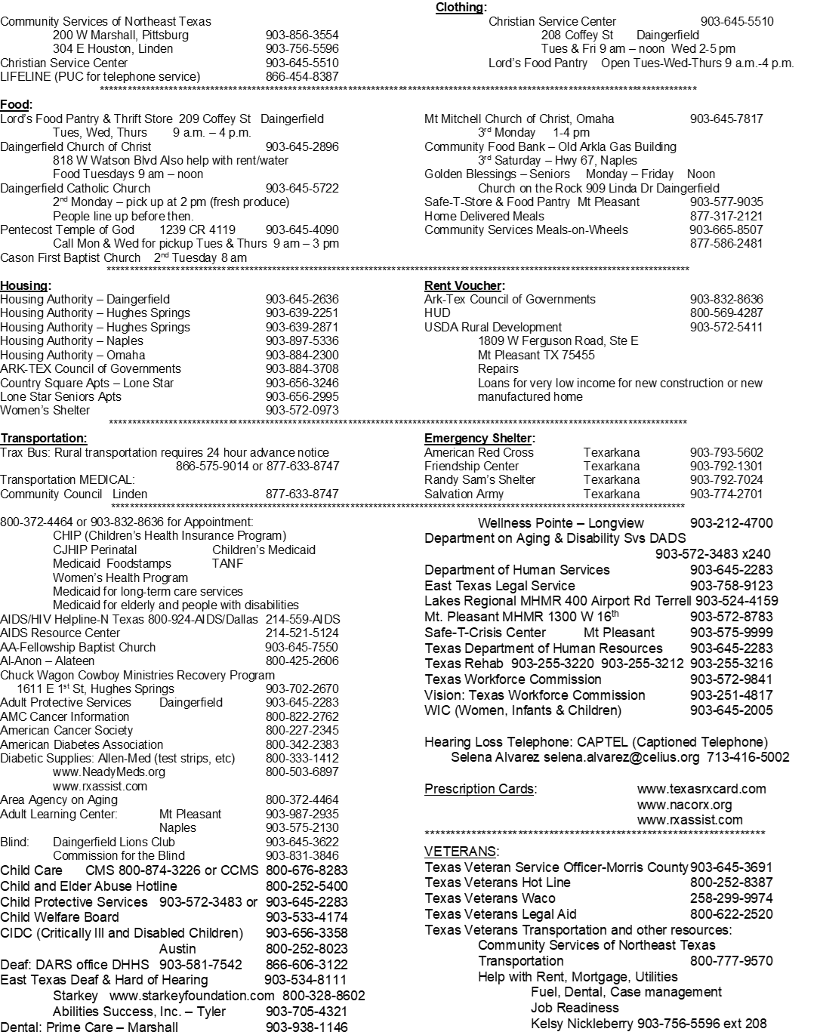
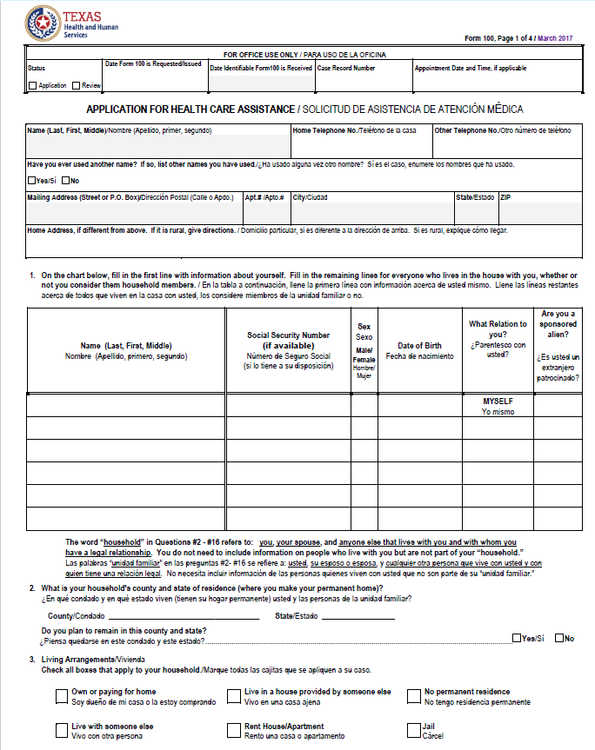

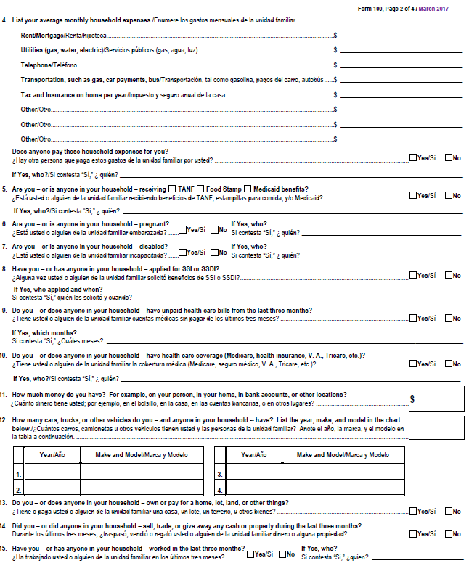
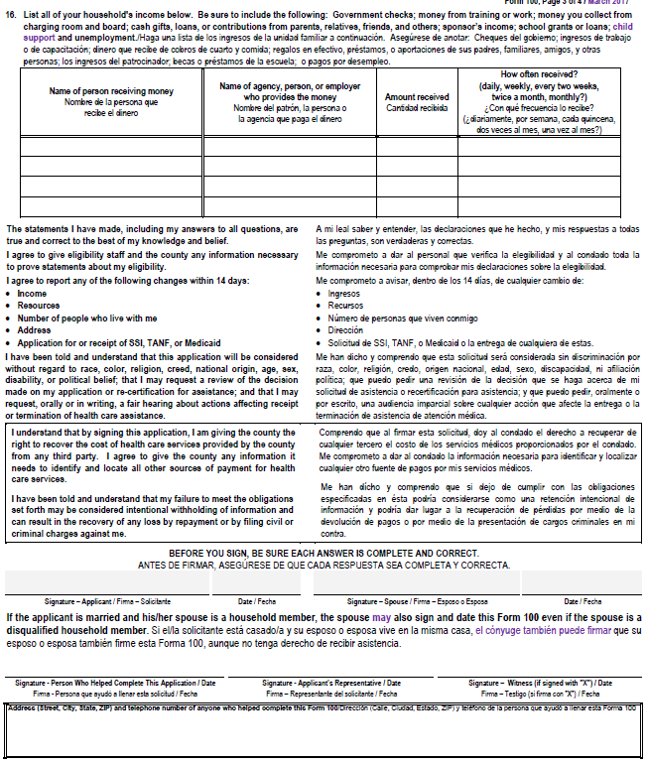

MORRIS COUNTY INDIGENT HEALTHCARE PROGRAM
STATEMENT OF SERVICES

- Clients are expected to seek ALL non-emergency medical care from their Primary Cary Physician. Make certain that your physicians understand the Indigent Health Care Program. They (physicians) may call this office for clarification.
- Hospital emergency rooms are not to be used except in matters of true emergency. If you seek routine medical attention – such as for a common cold – from an emergency room, you may be held responsible for the hospital bill and all related emergency room physician/lab bills.
- Morris County will pay for up to three (3) prescriptions per month and up to $30,000 per year in hospital, doctor, lab, x-ray, and skilled nurse facility expense OR 30 days of hospitalization, whichever comes first.
- Clients can be held responsible for the balance of charges not paid by Morris County, including full payment for prescriptions exceeding 3 per month
- Clients are responsible for informing providers of their eligibility with the Morris County Indigent Healthcare Program and for informing these providers of our billing address.
- Morris County Indigent Healthcare is not responsible for any medical claims received after our deadline. (Either 95 days from the date of service OR 95 days from the date of your completed application). *If a provider sends a bill to you, YOU MUST contact that provider and give them the above information so that they can bill our office.
- Clients MUST notify our office withing fourteen (14) days of any change of situation, such as changes in: income, insurance, address, property (including vehicles), household members, application/receipt of SSI, TANF, or Medicaid. FAILURE TO NOTIFY THIS OFFICE WITHIN FOURTEEN (14) DAYS MAY RESULT IN YOUR BECOMING INELIGIBLE FOR THIS PROGRAM.
- This program does NOT pay for ambulance service, eye exams or glasses, dental, medical equipment, prescriptions that are controlled substances, joint replacement of any sort including but not limited to knee or hip, etc.

If a change occurs that makes you ineligible and you fail to report the change as required, you may be held responsible for payment of any medical services received after you became ineligible, or you may be subject to prosecution under the Texas Penal Code.

I HAVE READ AND UNDERSTAND ALL CONDITIONS AS STATED ABOVE:

____________________________________ ____________________________
Signature Date

_____________________________________________
Printed Name

MORRIS COUNTY INDIGENT HEALTHCARE PROGRAM
BEHAVIORAL GUIDELINES

All Applicants and Qualified Clients are required to comply with all State and County policies and guidelines to receive services through the Morris County Indigent Health Care Program (MCIHCP).

- All Applicants or Qualified Clients are required to comply with behavioral guidelines established by the State of Texas.

- All Applicants or Qualified Clients who are rude and display disruptive or abusive language and behavior will not be seen. Our Personnel will be protected from dangerous situations; physical or combative confrontations are grounds for immediate termination from the Indigent Health Care Program.

- All Qualified Clients are expected to comply with the medical regime proposed by their health care providers: doctors, clinics, hospitals, etc.

- Medical Regime includes but is not limited to any instructions to refrain from use of alcohol, illicit drugs, and tobacco; as well as instructions for diet and exercise.
I HAVE READ AND UNDERSTAND ALL OF THE ABOVE GUIDELINES AND UNDERSTAND THAT FAILURE TO COMPLY WITH THESE GUIDELINES COULD RESULT WITH SUSPENSION FROM THE PROGRAM:
Applicant's Signature Date

Printed Name of Applicant

MORRIS COUNTY INDIGENT HEALTH CARE

FRAUD POLICY
. If a person knowingly provides false information for the purpose of qualifying for indigent health care, he or she is subject to Section 37.10 of the Texas Penal Code — Tampering with Government Record, Class 'A' Misdemeanor; and/or subject to Section 32.46 of the Texas Penal Code — Securing Execution of Document by Deception.
If a person knowingly, within the previous 24 months, transferred a countable resource for less than fair market value to qualify for indigent health care, that person's household is ineligible for two (2) years beginning with the date the resource was transferred, and if a person fails to disclose such a transfer, that person would also be subject to the criminal sanctions as set out in Section i.
. If a person fails to report a change in income, resources, or residence for the purpose of remaining eligible, he or she is liable for any benefits received while ineligible; and subject to criminal sanctions listed in Section l; and subject to Section 31.03 and/or Section 31.04 of the Texas Pena' Code, Theft and Theft of Services, respectively Class 'C' Misdemeanor to Second Degree Felony, depending on the value of the property or services taken.
IV. If a person knowingly alters an authorization document received from the indigent health care program for the purpose of changing the nature of health care authorized or the beneficiary of the health care authorized, he or she is subject to Section 37.10 of the Texas Penal Code, Tampering with Governmental Record, Class 'A' Misdemeanor. If the alteration involves the dispensing of controlled substances, the person is subject to Criminal sanctions pursuant to the Dangerous Drugs Act and the Controlled Substances Act.
The laws cited here are for illustrative purposes.
Upon finding of fraud, the client shall be administratively ineligible for IHC as follows:
First offense | 24 months from the date fraud was discovered
Second offense | 36 months from the date fraud was discovered
Third offense | 48 months from the date fraud was discovered
Additional offenses | +12 months for each additional offense

CONSEQUENCE OF FRAUD
If, after due process, a person is found to have intentionally misrepresented information in order to receive benefits, that person:
- Shall reimburse Morris County for the cost of benefits they were ineligible to receive
- Shall be administratively ineligible for Morris County IHC benefits in accordance with the above policy
Signature |  | Date
If you do not know the answer to a question you are asked or on the application, do not guess. I have read the above information and understand its contents.

Printed Name
•

MORRIS COUNTY INDIGENT HEALTH CARE

STATEMENT OF SERVICES
- Clients are expected to seek ALL non-emergency medical care from their primary care physicians. Make certain that your physicians understand the Indigent Health Care Program. They may call this office for clarification.
- Hospital emergency rooms are not to be used except in matters of true emergency. If you seek routine medical attention — such as for a common cold — from an emergency room, you may be held responsible for the hospital bill and all related emergency room physician/lab bills.
- Morris County will pay for up to three (3) prescriptions per month and up to $30,000 per year in hospital, doctor, lab, x-ray, and skilled nursing facility expense OR 30 days of hospitalization, whichever comes first.
- Clients can be held responsible for the balance of charges not paid by Morris County, including full payment for prescriptions exceeding 3 per month.
- Clients are responsible for informing providers of their eligibility with the Morris County Indigent Health Care Program and for informing these providers of our billing address.
- Morris County Indigent Health Care is not responsible for any medical claims received after our deadline. (Either 95 days from the date of service OR 95 days from the date of your completed application.) *If a provider sends a bill to you, YOU MUST contact that provider and give them the above information so that they can bill our office.
- Clients MUST notify our office within fourteen (14) days of any change of situation, such as changes in: income, address, property (including vehicles), household members, application/receipt of SSI, TANF, or Medicaid. Failure to notify this office within the fourteen days may result in your becoming ineligible for this program.
- This program does NOT pay for ambulance, eye exams or glasses, dental, medical equipment, replacements of any sort including but not limited to knee or hip, etc.
If a change occurs that makes you ineligible and you fail to report the change as required, you may be held responsible for payment of any medical services received after you became ineligible, or you may be subject to prosecution under the Texas Penal Code.
I HAVE READ AND UNDERSTAND ALL CONDITIONS AS STATED ABOVE:
Signature Date

Printed Name

MORRIS COUNTY INDIGENT HEALTH CARE
AUTHORIZATION FOR BACKGROUND CHECK
APPLICANT: SS: DOB:
SPOUSE: SS: DOB:
ADDRESS: _________________________________________________________________
_________________________________________________________________________
I understand that as part of the application process for benefits from the Morris County Indigent Health Care Program (MCIHCP) I am required to provide certain written documents to the MCIHCP office. I realize that my failure to provide such documentation will delay the receipt of benefits, if any, that may be eligible to receive.
I hereby give my permission to the MCIHCP to obtain background check from the Texas Workforce Commission, Department of Motor Vehicle Registration, Credit Bureau, and any other sources or databases that may need to be contacted to determine eligibility for the Indigent Health Care Program.
and spouse, if applicable, hereby authorize any public agency including the Social Security Administration, Medicaid, and Medicare to furnish Morris County or its agent information related to assets or any other sources of income to me held in my name and/or criminal history. I hereby release Morris County and all of its agents and employees, the public agencies providing such information and all employees of public agencies furnishing information, and all liability resulting from the furnishing of this information to Morris County. I certify that the statements made by me on this form and on my application for health care services are true, complete, and correct to the best of my knowledge and belief and are made in good faith. I understand that any false statements made herein or on my application for MCIHCP services will void further consideration for eligibility as it relates to my application for such services. I know and understand the MCICHP Fraud Policy.
I know that I must reapply for Indigent Health Care benefits every six months, and that if I do not reapply that could lose any benefits might have been receiving.
I have read all of the above, and I understand it.

Applicant Signature: Date:

Spouse Signature: Date:

AFFIDAVIT REGARDING MARITAL STATUS AND FINANCIAL SUPPORT

1. “My name is ____________________________________, I am over twenty-one years of age and I am competent to make this affidavit, I have personal knowledge of the following facts and they are true and correct. I am a legal resident of Morris County, and currently reside at ________________________________________________________________________________________

2. I am currently married to __________________________________, whose social security number is_____ _ ____________________.
We were married___________/___________/___________________.

3. I am currently separated from my spouse. We ceased living together as husband and wife on or about ______/_______/______
__________My spouse does not reside in the same residence that I do.
__________The present whereabouts of my spouse are unknown to me (OR)
My spouse’s current address is: _________________________________________________________________________________________

4. Financial Support (check one)
  - I currently receive no financial support of any sort from my spouse, nor have I received any financial support from my spouse in the past _ _months. I currently pay all my expenses solely from my income sources, and do not rely upon income produced by my spouse or my spouse’s property, or family members of my spouse to pay any of my expenses.
  - I currently receive financial support from my spouse. Monthly assistance, which includes cash and/or in-kind assistance totals $ .__________________.
5. I am applying for Indigent Health Care from Morris County and understand that representatives of the County are relying upon the facts stated herein to determine my eligibility, including the information regarding financial resources.

6. I warrant and attest that the information I have furnished the Morris County Indigent Healthcare Program in connection with my request for assistance is true and correct, and is complete.

I HEREBY AFFIRM UNDER PENALTIES OF PERJURY THAT THE ABOVE FACTS ARE TRUE AND CORRECT. I FURTHER UNDERSTAND AND AGREE THAT MORRIS COUNTY MAY REQUIRE RESTITUTION FROM ME SHOULD IT BE DETERMINED THAT ANY INFORMATION I HAVE PROVIDED TO THEM IS FALSE OR MISLEADING. I UNDERSTAND THAT THE MORRIS COUNTY INDIGENT HEALTH CARE PROGRAM MAY REFER ANY FALSE STATEMENTS CONTAINED HEREIN FOR CRIMINAL PROSECUTION.

APPLICANT:

___________________
Date Signature

Printed Name

Sworn to and subscribed before me on this _____ day of _______________________, 20____.

___________________________________
Notary Public
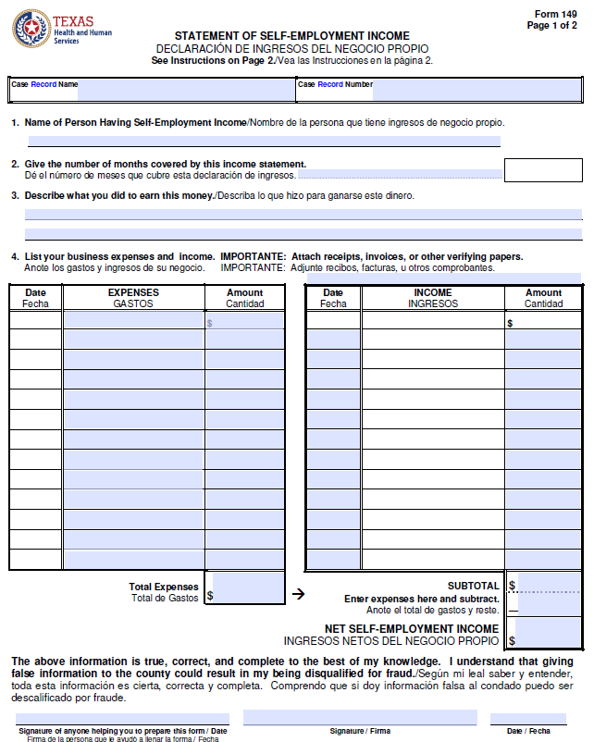
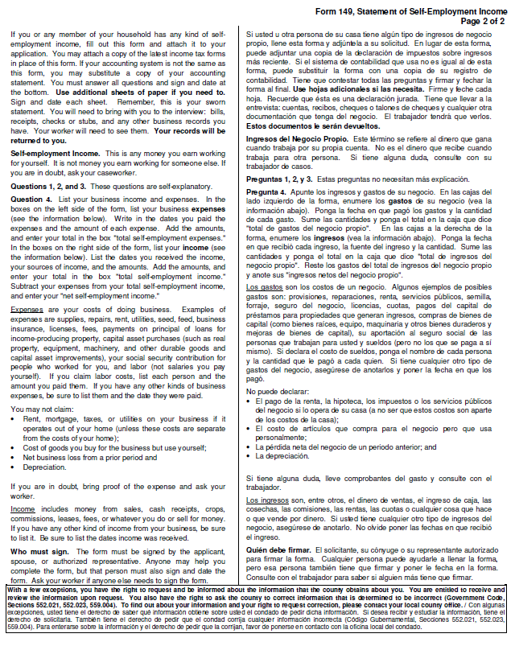

MORRIS COUNTY INDIGENT HEALTHCARE PROGRAM
(*TO BE COMPLETED BY EMPLOYER)
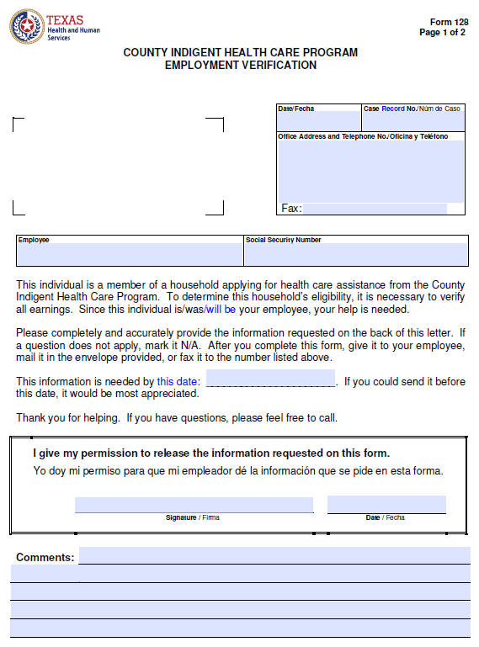
MORRIS COUNTY INDIGENT HEALTHCARE PROGRAM
(*TO BE COMPLETED BY EMPLOYER)
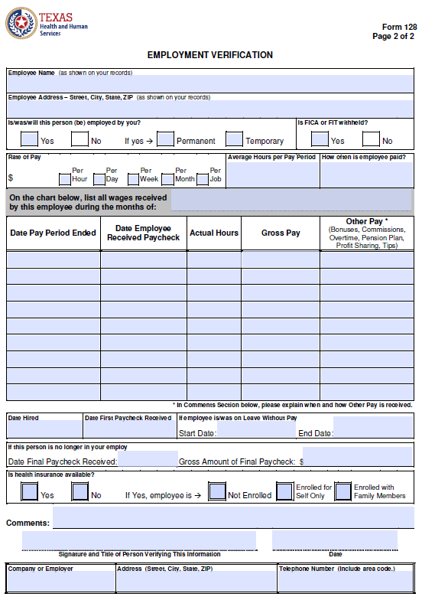

MORRIS COUNTY INDIGENT HEALTHCARE PROGRAM

Information about your County Indigent Health Care Program (CIHCP) case is confidential. In order for Morris County Indigent Healthcare staff to speak with a family member or friend regarding your case that individual must be designated below.

Having someone listed below will allow the Morris County Indigent Healthcare staff to release and share information regarding your case with/to them to act on your behalf as your authorized representative. This should only be utilized as an option in emergencies when you cannot be present.
- Listing an individual below allows them to pick up your Monthly Eligibility Letter in rare and emergent circumstances when you are unable. A representative must provide proof (photo identification, social security card, etc.) of their identity before requested information is released. A copy will be kept in file.

Please Print the Individual(s) You Approve as a Representative Below
Name, Relationship and Phone Number:

___________________________________ ____________________________ ___________________
Name Relationship Phone Number

___________________________________ ____________________________ ___________________
Name Relationship Phone Number
_________ I do not wish to designate any representative at this time.

_________ I understand it is my responsibility to inform my Case Manager in the event I want to change or
update who is listed and can act as my authorized representative, changes will only take affect by completing an updated form.

Client Name Printed:_________________________________________________

Client Signature: ___________________________________________________

Date:_______________

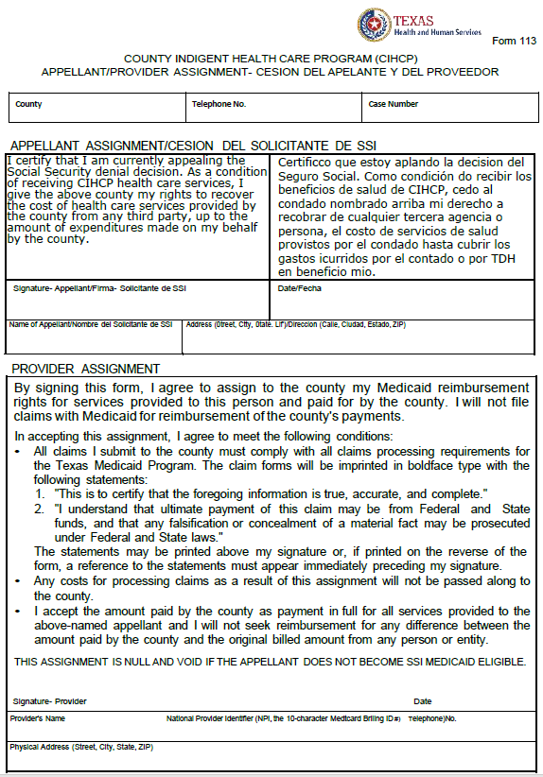

THE FOLLOWING
TWO (2) PAGES
ARE TO BE COMPLETED
BY
ANYONE
GIVING YOU ASSISTANCE.
MAKE CERTAIN ALL BLANKS ARE FILLED AND EACH PAGE SIGNED AND DATED
RETURN WITH YOUR APPLICATION

MORRIS COUNTY INDIGENT HEALTHCARE
ASSISTANCE RECEIVED FORM

(Household providing support) (Applicant)
by providing the following things:
_____ How much cash do you give each month?

Pay utilities directly to company
Pay medical bills and/or prescriptions directly to DR. or pharmacy
Food and clothing at the time of purchase
_____ Payment of house loan or rent directly to landlord or the loan company

Other

The above Applicant does live with me/us
The above Applicant does not live with me/us.
I state that the above named Applicantis is not employed.
The above statements made by me (us) regarding the above household are true and correct. I understand that this statement will be part of a government record, and that any false entry made with the intent to defraud Morris County or any other person may constitute a third degree felony, punishable by a fine not to exceed $10,000 and confinement in the State Penitentiary for the period of two to ten years
Date Signature of person(s) providing support
_______________________________________________
Street Address

Mailing Address

City-Zip / County
Phone Number _______________

MORRIS COUNTY INDIGENT HEALTH CARE

CONTRIBUTIONS FORM
Name: ____________________________

The person named above has stated that you provide help to their household. Please provide dates, amounts, and whether this assistance will continue.
When did the assistance start?: ________________________
Was your help a loan? YES NO (please circle) A loan is money that is expected to be repaid, and the household can explain how and when the money will be paid back.
Date | Amount | Person Receiving Loan | Date to be Repaid/How to be Repaid
Did you make a contribution to the household? YES NO (please circle) A contribution is money you give to the household that is not expected to be paid back.
Date | Amount | Person Receiving Money | Purpose of the Contribution
Did you pay any bills for the household as a vendor payment? YES NO (please circle) A vendor payment is a payment you make directly to the person or company that bills the household for a service or directly to the company for a purchase.
Date | Amount | Person Billed | Person/Company Paid | Purpose

Printed Name: Address:

Signature: Phone:

Relationship: Date:

